
2025/2026
Lab 1: Object and Class

FAKULTI SAINS KOMPUTER DAN MATEMATIK
DATA STRUCTURE & ALGORITHM

VERSION 1
Name: MUHAMMAD AMIER YUSHAIMY BIN MOHAMED YUNNUS
Matric Number: S80620
Lab:
Date: Click or tap to enter a date.
Table of Contents
INSTRUCTIONS 1
TASK 1: BASIC KNOWLEDGE ON OBJECT AND CLASS 2
TASK 2: POST-LABORATORY PROBLEMS 10

INSTRUCTIONS

Manual makmal ini adalah untuk kegunaan pelajar-pelajar Fakulti Teknologi Kejuruteraan Kelautan dan Informatik, Universiti Malaysia Terengganu (UMT) sahaja. Tidak dibenarkan mencetak dan mengedar manual ini tanpa kebenaran rasmi daripada penulis.
Sila ikuti langkah demi langkah sebagaimana yang dinyatakan di dalam manual.

This laboratory manual is for use by the students of the Faculty of Ocean Engineering Technology and Informatics, Universiti Malaysia Terengganu (UMT) only. It is not permissible to print and distribute this manual without the official authorisation of the author.
Please follow step by step as described in the manual.

TASK 1: BASIC KNOWLEDGE ON OBJECT AND CLASS

ObjectiveS
At the end of this lab, the students are able to
- Write a class with instance variable fields of a user
- Write constructors with and without parameters.
- Access class members from member methods of the class.

Estimated Time
[120 Minutes]

steps:
In this lab, the Rectangle class will be defined.
A rectangle has a height and width, and given this data, the area and perimeter of a rectangle can be determined. Therefore, the class Rectangle should define data members: height and width. Since each Rectangle object stores its own values for these variables, height and width are instance variables. The methods are the method's that determine the area and perimeter of a Rectangle object and are, therefore, instance methods. The Rectangle class contains only instance variables and instance methods.
The following diagram is a diagram of a Rectangle object showing the instance variables width and height and the methods area and perimeter. The state of the object are the values of its data members. Since the state of this object has been set, also illustrated are the values returned when the area and perimeter methods are invoked on the object.
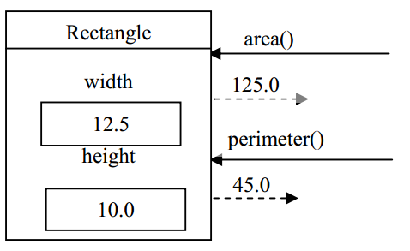
1.1 Testing the utility class
- Run the following code and place as Rectangle.java
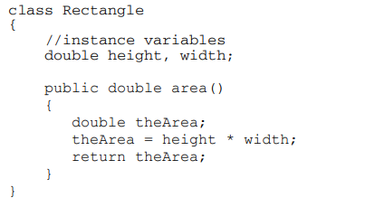
- Record the error message.
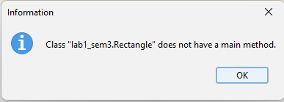

- Why does the error happen?
Because class doesn’t have main method to run.

- Enter and save this in a file called RectangleTest.java.
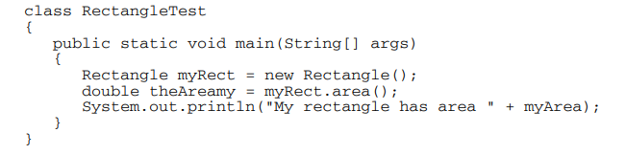
- Compile the program RectangleTest.java. Execute the program and record the results.
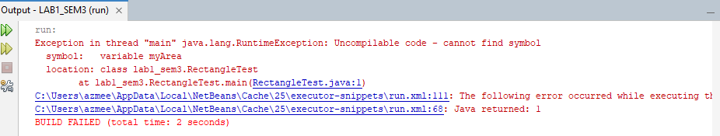

- Currently, you can access the values of width and height directly by joining the variable to the name of the object using the dot operator. Add the following statements to the end of the main method.

Predict the output of the new program.
The value is 0

- Compile and execute the program. Record the results. Was your Step 5 prediction correct? If not, correct your answers.
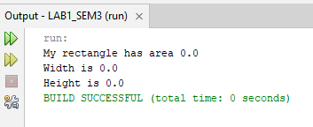

- Modify the program by adding these statements at an appropriate place in the main method so that the area of myRect is no longer 0.
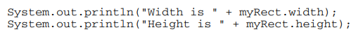
Compile and execute the program. Record the results.
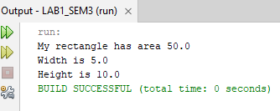

1.2 Access Modifier: private
- Being able to directly access the instance variables of an object (Rectangle) from an outside class (RectangleTest) is considered to be an inappropriate practice in object-oriented languages. To prevent this, the instance variables of a class should be modified by the access modifier private. Modify the Rectangle class by inserting the private modifier in the data member declaration statement:

private double width, height;

Compile the modified program. Record the compiler error messages.
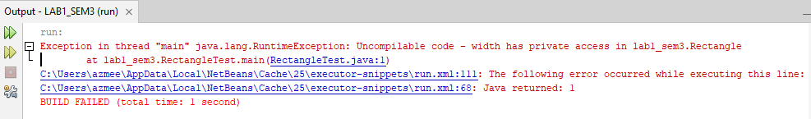

1.3 Accessor Methods
- In the Rectangle class, insert the code for the method getWidth which has no parameters and returns a double

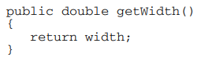
Compile the code. Then, insert a similar method to give the user, or client, access to the height of a Rectangle.
- Modify the client class, RectangleTest, to correctly access the width and height of the Rectangle object.
This is an example of code to access the width of the Rectangle object.
Insert the similar code to access the height of the Rectangle object.
Compile RectangleTest.java and execute the program. Record the results.
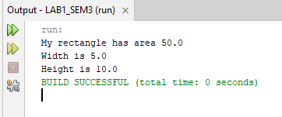

1.4 Mutator Methods
- The completed method should be added to the Rectangle class:
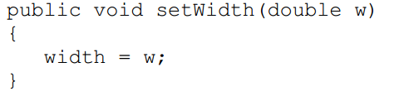

Add the methods setWidth and setHeight to the Rectangle class. Make changes to RectangleTest to correctly use these methods. Your Rectangle class should now be:
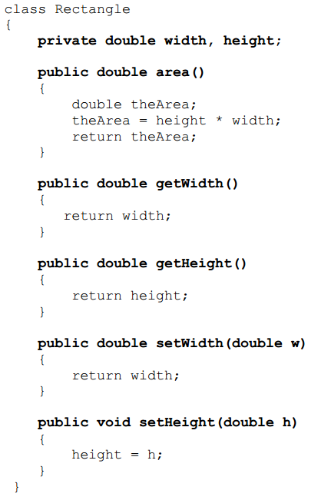
And, your RectangleTest class should now be:

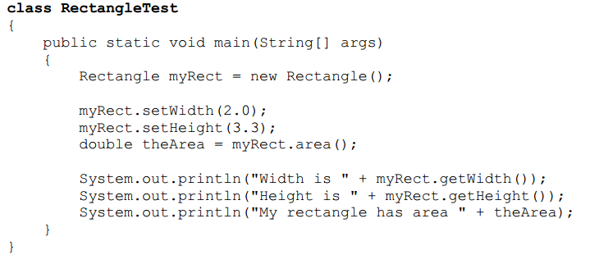
Compile RectangleTest. Execute the program and record the results.
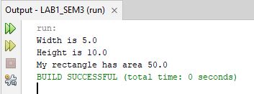

Modify the Rectangle class by adding the constructor, placing it after the declaration of the instance variables, and before the definitions of the existing methods. This location is not mandatory, but it makes the code more readable.

Also, do the following to modify the class RectangleTest class
  - Comment out the two statements in main that invoke the set methods.
  - Change the statement that creates the Rectangle object from

to

Compile and execute the modified program. Record the results
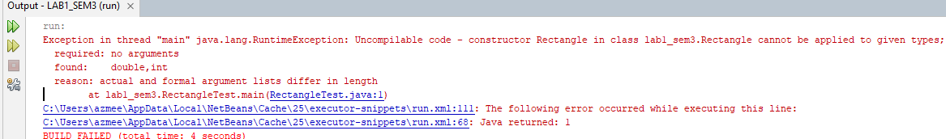

  - Writing a Constructor

- A constructor must have the same name as the class name. Therefore, a constructor used to construct a Rectangle object, must be named Rectangle. We say that a constructor is a special type of method because it does not have a return type and because it can only be used in conjunction with the new operator. A constructor that initializes the height and width of a Rectangle object would take the form

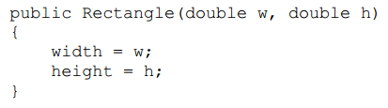

Add the constructor to the Rectangle.java.

Compile and execute the modified program. Record the results
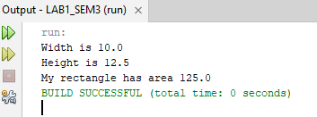

  - Completing the Rectangle class

Now, complete the Rectangle class by
- Adding a method to find the perimeter of a Rectangle object with the header that calculates and returns the perimeter of the rectangle.
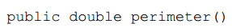

Compile and execute the modified program. Record the results
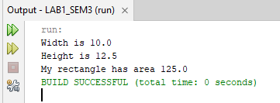

TASK 2: POST-LABORATORY PROBLEM

objective
To test the understanding of basic concepts and terminologies in object and class.

task description
This task is basically to test the understanding of basic concepts and terminologies in object and class.

estimated time
[60 Minutes]

* The task will be given during the lab session.

